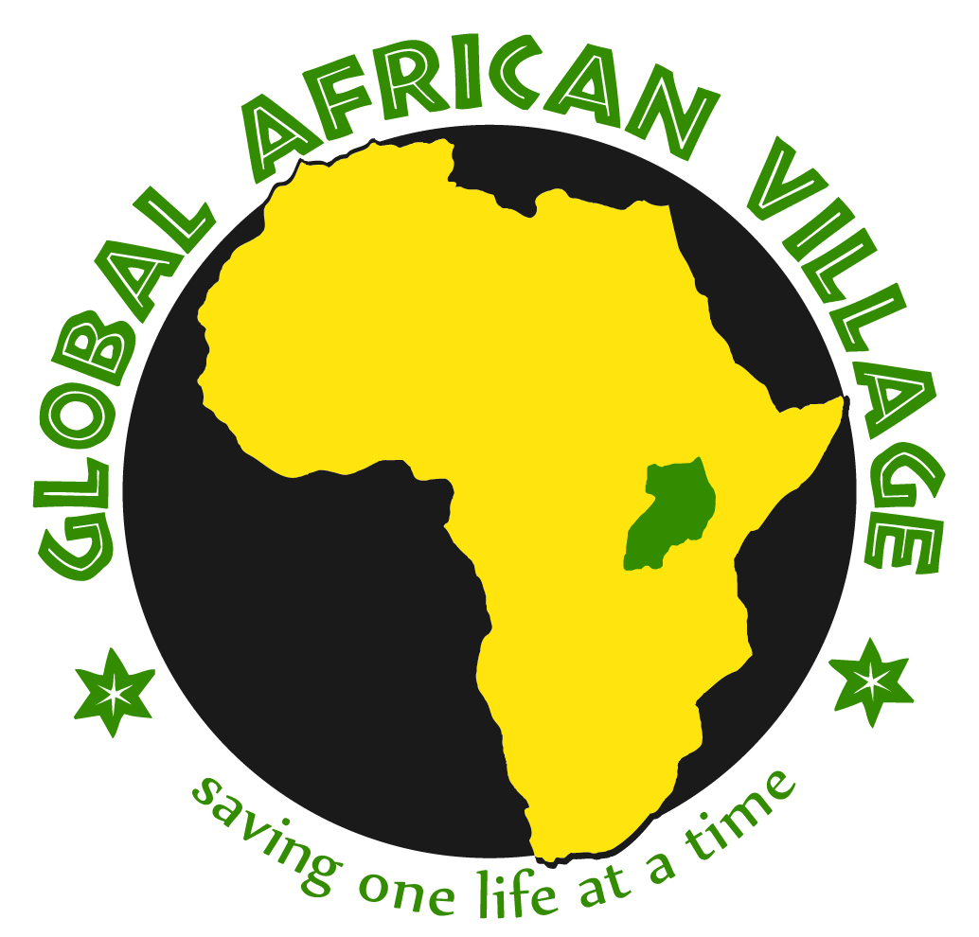
Global African Village Board Meeting
July 9, 2011
Toronto, Ontario

In attendance: Sebastian Wanzama-Piro, Maura Fioroni, and Sharon Green
- Sebastian will be leaving for Uganda in three days, and he will be there for several months. He is taking $4,000 from recent fundraising activities for our projects.

  - We concurred that it would be best to use $1,200 donation from Mary Willcox of Idaho Falls, ID, to help Esta Nabulwala complete her training in Early Childhood Education. Esta has been a faithful volunteer at Joe’s Playhouse. Her education will enable her to teach more students, so this donation will have a “ripple effect.”
  - Maura recommended that the $1,067 raised by students at Errick Road Elementary School in Wheatfield, NY, should be used for the kids at Joe’s Playhouse. We will use these funds for scholastic materials and food for the children and for professional development for the all-volunteer staff of teachers.

- Sebastian will try to visit one of the 30 rain barrel projects installed by the Uganda Water Project in Rochester, NY – either in Mbale or Jinja. Meanwhile, Sharon will contact Niagara University student Marissa McCarthy, who volunteers for the Uganda Water Project (based in Rochester, NY) about collaborating on fundraisers.

- In some underdeveloped countries, girls and women don’t attend school while menstruating so we discussed the possibility of raising money for feminine hygiene products. Sebastian reported that Bagishu women use cloth, and although some don’t go to school while menstruating, others do. Maura raised the question of how girls and women would dispose of sanitary products and Sebastian explained that before we undertake such a project, education would be necessary. This idea was tabled for now.

- The Yetana Fish Pond project was started earlier this year, when villagers dug a 65” x 22” x 4” pond and laid PVC pipe. Recent funds that we raised – especially the $300 donation that we received yesterday from Canisius College SIFE students to complete the Yetana Fish Pond – will enable the villagers to complete this important project by buying fish and fish food as well as materials to enclose the pond with a fence. While in Uganda, Sebastian will price medium-sized barrels which could help with agricultural projects.

- Sebastian plans to approach some local officials to officially open the fish pond.

- Sebastian will deliver the 50 birthing kits donated by the Cheektowaga-Lancaster, NY, Zonta Club to clinics in rural Uganda. He will also deliver the Red Cross short-wave radio donated by SIFE at Canisius College. This device can also be used to charge cell phones, which should facilitate communication between Canisius SIFE and grant recipients in Uganda.

- Maura suggested the image of a rainbow, connecting two worlds and the human connections that we have built through Global African Village.

The date and time for the next Board meeting will be determined after Sebastian returns from Uganda.
www.globalafricanvillage.org

